Investigation of Tumour Infiltrating Lymphocytes as Indicators of Prognosis and Treatment Response in Cholangiocarcinoma
Grant Reference: 3878740
Applicant: Dr Isioma Egbuniwe
Address: Division of Cancer and Stem Cells, University of Nottingham Biodiscovery Institute, University Park, Nottingham NG7 2RD
Supervisor: Prof David Bates
Background:
Cholangiocarcinoma (CCA) is an aggressive malignancy arising from epithelial cells of the biliary tract. It’s dismal prognosis (5 year survival <10%), and rising incidence make this an important clinical problem to be addressed (1). Further study of molecular mechanisms underpinning this disease would therefore aid in identification of potentially actionable therapeutic targets for improved patient outcomes.
CCA tumours upregulate expression of vascular endothelial growth factors (VEGFs) which bind to receptors (VEGFR1 and VEGFR2) expressed on endothelial cells to induce tumour vessel growth, metastasis and the ability to repress T cell-mediated anti-tumour immune responses (2, 3). Synergistic interactions between VEGF and immune checkpoint inhibitors such as anti-CTLA4, anti-PD1 and anti-PDL1 have been demonstrated in many cancers (4-7). This project therefore aims to investigate possible synergistic combinations of targeted anti-angiogenic therapies (e.g. VEGF inhibitors) and immunotherapies which would be of therapeutic benefit in CCA.

Original Aims (copied from original application):
1. Isolate and phenotype tumour-infiltrating lymphocytes (TILs) from human cholangiocarcinoma (CCA) tumours. 2. Develop ex vivo co-culture models using primary CCA tumour cell lines, patient peripheral blood lymphocytes and patient tumour-derived lymphocytes.
3. Test the effects of anti-angiogenic therapy and checkpoint inhibitor therapy on anti-CCA tumour responses using ex vivo co-culture models.

Results:
Aim 1: Using a combination of enzymatic tissue digestion and multi-colour flow cytometry, TILs were isolated from surgically resected CCA tumours from UK patients (n=6), along with peripheral blood mononuclear cells (PBMCs) from matched patient blood samples, and analysed to determine proportions of T lymphocyte subsets (CD3, CD4 and CD8), B lymphocytes (CD20), as well as the expression of immune regulatory checkpoint molecules CTLA-4, PD-1 and PDL-1. We demonstrated that T and B cell subsets could be reliably identified within freshly resected CCA tumours (Figure 1a). Furthermore, using immunohistochemistry on FFPE sections from CCA tumours and matched non-tumour tissue (n=20), we showed that proportions of total T cells (CD3+), helper T cells (CD4+) and cytotoxic T cells (CD8+) were greater within CCA tumours compared with adjacent non-involved bile duct tissue (Figure 1b). Interestingly, unlike T cell subsets, very few B cells (CD20+) appeared to accumulate within tumours potentially indicating that these cells might not play a major role in the immune response to CCA tumours (Figure 1b). Disappointingly, we were unable to detect significant differences by flow cytometry in the expression of checkpoint molecules when comparing between CCA tumours, non-involved bile duct tissue and the peripheral circulation (Figure 1c).
CCA is most prevalent in regions of South-East Asia including Thailand, where there is a high risk of liver fluke infection. Cases diagnosed within Western countries are however more associated with chronic inflammatory liver conditions such as Hepatitis B and C infections, as well as autoimmune diseases including Primary sclerosing cholangitis. We therefore hypothesized that these differences would be represented within the tumour microenvironment. Taking advantage of our access to CCA tumours from Thai patients through an ongoing collaboration and using Nanostring™ Digital Spatial Profiling technology we preliminarily undertook spatially resolved quantitative analysis of tumour stroma and immune cells within UK and Thai CCA tumours (Figure 2a). Our data revealed differential clustering of stromal immune signatures (including co-stimulatory molecules CD40, CD80 and CD86 ) within each tumour type, indicating that UK and Thai CCAs potentially represented distinct tumour entities (Figure 2b).

Aim 2: In establishing ex vivo co-cultures, we sought to model a clinically relevant system that would accurately reflect complexities seen in vivo. We initially used cancer cells isolated from CCA patient tumours, cultured with matched tumour-associated fibroblasts within a basement membrane gel. While conducive to co-culturing isolated T cells with CCA tumour cells, we were however unable to reliably assess phenotypic changes in T cell markers post-culture as the gel system was incompatible with downstream flow cytometric analysis. To overcome this problem, we next utilized a 3D “spheroid” culture system which involves growing tumour cells in a significantly lower quantity of supporting basement membrane gel. This allows for growth and interaction of cultured tumour cells within a spatially organized model more in keeping with in vivo tumour growth. We successfully used this system to co-culture CCA tumour cells with human peripheral blood T cells, following which increased surface expression of PD-1 could be detected on a subset of memory T cells by flow cytometry (Figure 3). This demonstrates the utility of our system for the assessment of immune cell functionality within the CCA tumour microenvironment.

Conclusions:
Aim1: Our results demonstrate the presence of tumour-infiltrating T and B lymphocytes which preferentially accumulate within CCA tumours compared to adjacent non-tumour bile duct tissue. This highlights the potential importance of an immune component to interactions within the CCA tumour microenvironment. Furthermore, differential stromal and immune gene expression signatures highlight possible differences in the immunobiology of CCA tumours arising from different aetiologies.
Aim 2: Our data further shows the utility of an in vitro 3D co-culture system for the assessment of immune cell functional capabilities within the tumour microenvironment.

How Closely Have the Original Aims been Met:
We have mostly achieved the first two aims as set out in our original proposal. This data has contributed to an MRC program grant application as part of which further in-depth spatially resolved characterization of the CCA tumour microenvironment will be carried out using Nanostring™ digital imaging technology. This will allow for better assessment of immune checkpoint markers and overcome technical challenges we’ve encountered in this regard. We have however been unable to progress to our final aim of testing the effects of different therapies using our in vitro system, due to initial difficulties encountered with optimising the system. We hope to achieve this utilising our 3D spheroid model going forward.

Outputs from the study in which the Pathological Society has been acknowledged:
- MRC program grant application: Understanding the cholangiocarcinoma tumour microenvironment (Dr Isioma Egbuniwe – Co-applicant).
- Poster presentation at University of Nottingham Annual Clinical Academic Research Showcase, Dec 2019 (Dr Isioma Egbuniwe awarded prize for overall best presentation by a Clinical Lecturer).
- Digital pathology image highlighting cellular interactions within the cholangiocarcinoma microenvironment, selected as cover art for February 2020 issue of Cancer Research scientific journal (Dr Isioma Egbuniwe acknowledged as contributing to image analysis and production).

References:
1. Abou-Alfa GK, Andersen JB, Chapman W, Choti M, Forbes SJ, Gores GJ, et al. Advances in cholangiocarcinoma research: report from the third Cholangiocarcinoma Foundation Annual Conference. J Gastrointest Oncol. 2016;7(6):819-27.
2. Tang D, Nagano H, Yamamoto H, Wada H, Nakamura M, Kondo M, et al. Angiogenesis in cholangiocellular carcinoma: expression of vascular endothelial growth factor, angiopoietin-1/2, thrombospondin-1 and clinicopathological significance. Oncol Rep. 2006;15(3):525-32.
3. Yoshikawa D, Ojima H, Iwasaki M, Hiraoka N, Kosuge T, Kasai S, et al. Clinicopathological and prognostic significance of EGFR, VEGF, and HER2 expression in cholangiocarcinoma. Br J Cancer. 2008;98(2):418-25.
4. Ott PA, Hodi FS, Buchbinder EI. Inhibition of Immune Checkpoints and Vascular Endothelial Growth Factor as Combination Therapy for Metastatic Melanoma: An Overview of Rationale, Preclinical Evidence, and Initial Clinical Data. Front Oncol. 2015;5.
5. Carlo MI, Voss MH, Motzer RJ. Checkpoint inhibitors and other novel immunotherapies for advanced renal cell carcinoma. Nat Rev Urol. 2016;13(7):420-31.
6. Allen E, Jabouille A, Rivera LB, Lodewijckx I, Missiaen R, Steri V, et al. Combined antiangiogenic and anti-PD-L1 therapy stimulates tumor immunity through HEV formation. Sci Transl Med. 2017;9(385).
7. Schmittnaegel M, Rigamonti N, Kadioglu E, Cassara A, Wyser Rmili C, Kiialainen A, et al. Dual angiopoietin-2 and VEGFA inhibition elicits antitumor immunity that is enhanced by PD-1 checkpoint blockade. Sci Transl Med. 9. United States: American Association for the Advancement of Science.; 2017.

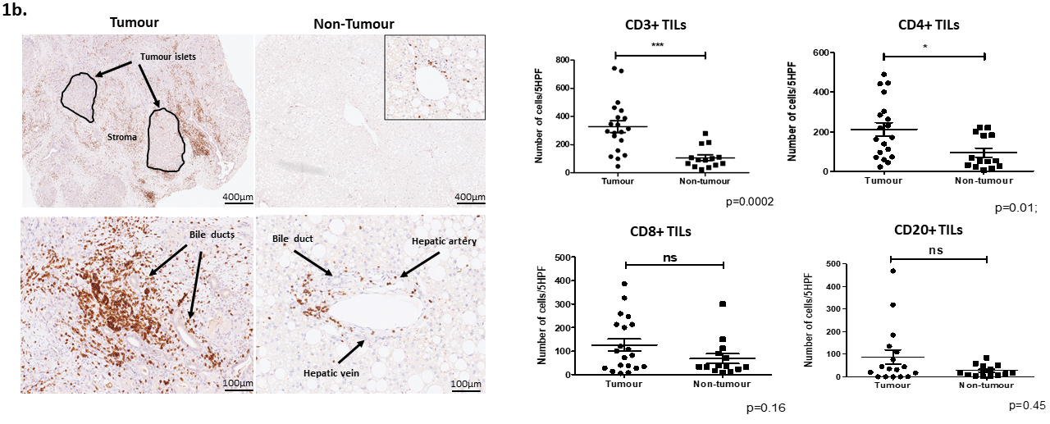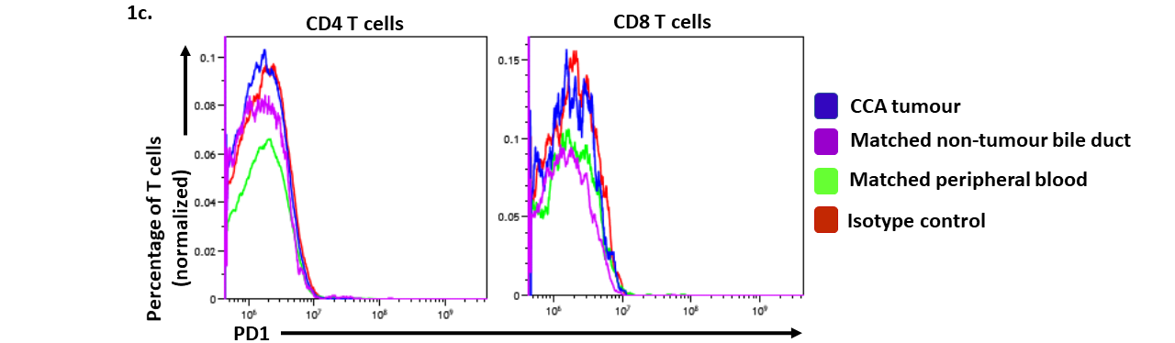
Figure 1. Immune cells preferentially accumulate within cholangiocarcinoma (CCA) tumours compared to non-tumour bile duct tissue. (a) T and B lymphocyte populations are reliably identified within freshly resected human CCA tumours by flow cytometric analysis. Representative plot shown for one patient sample. (b; left panel) Immunohistochemical staining of CCA tumours and matched non-involved bile duct tissue shows tumour-infiltrating CD3+ T cells (brown dots) within tumour islets and stroma. Comparatively fewer CD3+ T cells were present within non-involved tissue obtained from the same patient sample. Original magnification = 20x. (b; right panel) Quantification of stained FFPE samples reveals increased numbers of helper (CD4+) and cytotoxic (CD8+) T cells within CCA tumours compared to non-tumour bile duct tissue. Lymphocytes counted within 5 most densely populated areas, and mean number of cells plotted. Each data point represents an individual patient. Significance calculated using a Mann-Whitney U Test. Error bars represent mean ± SEM. (c) No difference is seen in PD1 expression on CD4+ and CD8+ T cells isolated from patient CCA tumours (blue histogram), matched non-tumour bile duct (purple histogram) and matched peripheral blood (green histogram). All samples were also compared to background levels of PD1 expression using a matched isotype control (red histogram).

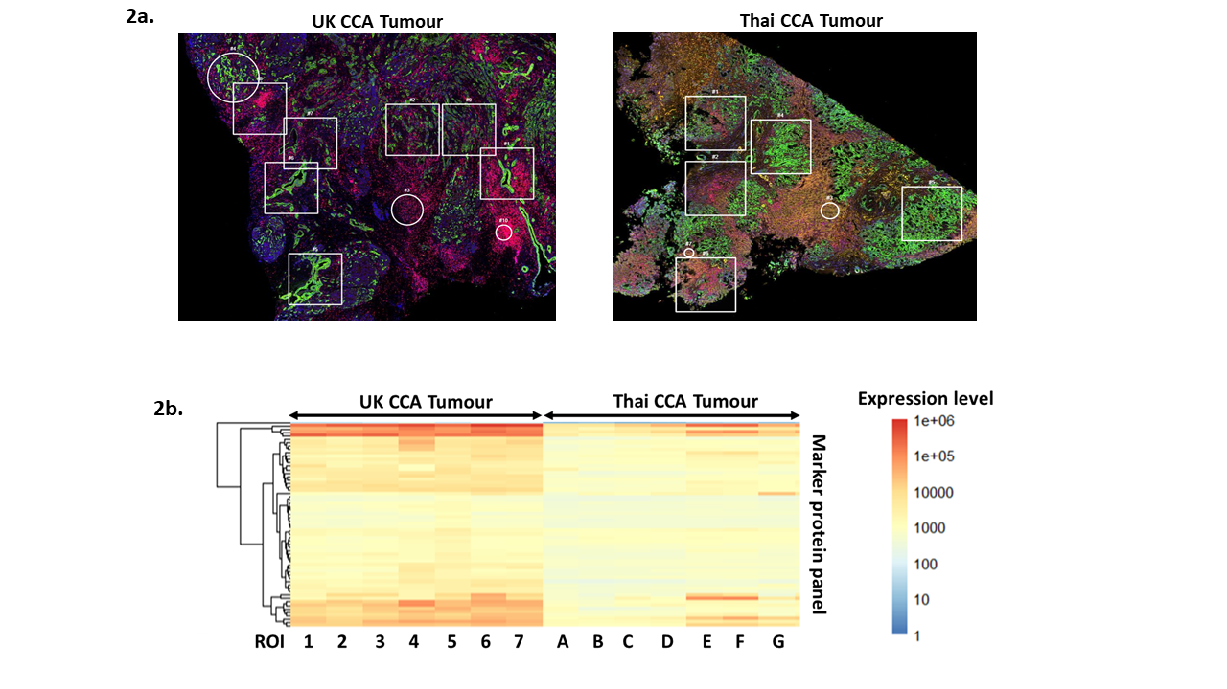

Figure 2. UK and Thai CCA tumours potentially represent distinct pathological entities. CCA tumours from a UK patient (a; left panel) and a Thai patient (a; right panel) were stained to identify tumour cells (green = pan-cytokeratin), T cells (red = CD3), stromal cells (yellow = smooth muscle actin) and cell nuclei (blue = DAPI stain). (2b) Regions of interest (ROIs – white boxes/circles) representing tumour-rich, immune-rich or stroma-rich areas were further probed to generate a heatmap of stromal and immune signatures showing differential clustering patterns for both tumours. Columns represent different ROIs. Rows represent expression levels of different proteins.

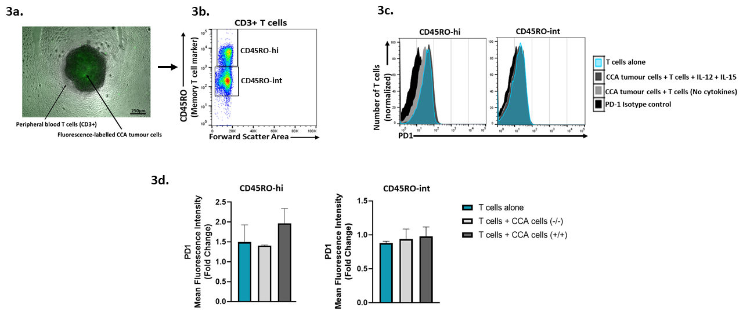

Figure 3. Establishing a 3D tumour-immune cell co-culture model of CCA. (a) Green fluorescence-labelled CCA tumour cells grown as spheroids and cultured with FACS-sorted peripheral blood CD3+ T cells for 72 hours. (b-d) Expression of PD1 on memory T cells (CD45RO-hi) co-cultured in the presence or absence of CCA tumour cells provides evidence of tumour cell: immune cell interactions within an in vitro 3D environment.

