Evaluating steroid hormone receptor profiles in triple negative breast cancer

Helena Bean

MSc Molecular Medicine

The University of Leeds

August 2018

Abstract
TNBC lacks oestrogen (ERa), progesterone (PR) and human epidermal growth factor (Her2) receptors, which are required for response to the current targeted therapeutics. This study will explore the hypothesis that other members of the steroid subclass of nuclear receptors may provide alternative pharmacological targets in TNBC (1).
The profiles of GR, MR, AR and ERb were determined in 39 TNBC cases. Immunohistochemistry (IHC) was used to quantify the proportion of tumour cells expressing each receptor, and correlations between receptor status and clinical outcome were determined. Pairwise analysis of steroid receptor expression identified no direct correlation between receptor expression, but KM analysis suggests that high expression of GR and low expression of AR are linked to poorer outcome. 3D models using breast cancer cell lines were also developed.

Contents
Abstract 2
1.0 Introduction 5
1.1 Current treatment options in BC 5
1.2 Steroid hormone receptors 5
1.4 Hypothesis and Aims 6
Evidence now suggests significant redundancy between the actions of the six major steroid receptors. 6
Hypothesis 6
Aims 6
2.0 Methods 7
2.1 Cell culture 7
2.1.1 Cell lines 7
2.1.2 Recovery of cryopreserved cells 7
2.1.3 2D cell culture 7
2.1.4 Cryopreservation of cells: 7
2.1.5 3D spheroid cell culture 7
2.2 Immunohistochemistry 7
2.2.2 Preparation of sections from cell pellets: 7
2.2.3 Preparation of sections from spheroid cultures: 8
2.2.4 Immunohistochemistry: 8
2.2.5 Quantification of stained sections 8
2.3 Kaplan Meier (KM) survival analysis 8
2.4 Statistical analysis 8
3.0 Results 9
3.1.1 Staining of TNBC tissue sections 9
3.1.2 Comparative steroid receptor staining serial sections 12
3.1.3 Testing different ERβ antibody clones 14
3.2 Quantification of steroid receptor expression levels in TBNC 14
3.2.1 Image analysis using QuPath 14
3.2.2 Steroid receptor expression in TNBC tumours 17
3.2.3 Pairwise correlation of steroid receptor expression in TNBC sections 18
3.3 Correlation of steroid receptor expression and disease progression 19
3.4 Developing a model to study steroid receptor crosstalk in TNBC 21
3.4.1 Steroid receptor expression in cell lines 21
3.4.2 Developing a 3D spheroid model 22
3.4.3 Steroid receptor staining of spheroid culture 22
4.0 Discussion 25
4.1 Staining of TNBC sections 25
4.2 Survival analysis and therapeutic implications 25
4.3 Cell models 25
5.0 Conclusions and future work 25
6.0 References 26

Introduction

1.1 Current treatment options in BC
In the UK, approximately 55,000 new cases of breast cancer (BC) are diagnosed every year, with around 12,000 deaths (2). BC is a heterogeneous disease, with differing treatment responses and prognoses reported depending on the clinical and histopathological features.

1.2 Steroid hormone receptors
The hormonal influence on the progression of BC was first proposed in 1896, leading to the current classification system of breast tumour types according to hormone receptor profile, and the subsequent development of endocrine targeting therapies (3, 4). There are six main steroid receptors, and each works in a similar way. Upon binding of hormone, the receptor becomes activated, moves into the nucleus and regulates gene transcription (figure 1).

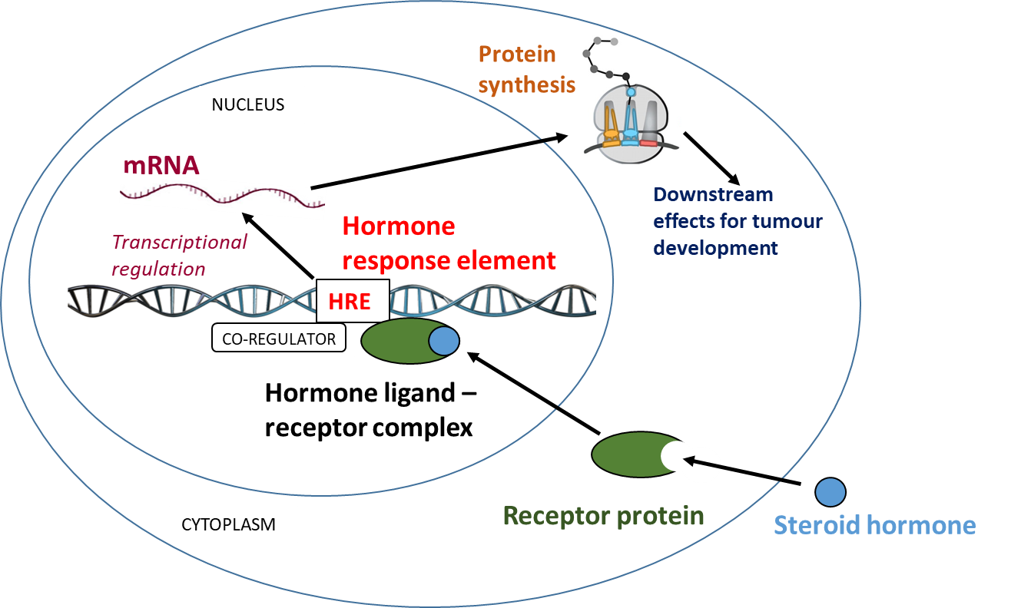
Figure 1: Schematic diagram of the steroid hormone receptor pathway: Binding of a steroid hormone such as oestrogen, progesterone, androgen, cortisol or aldosterone to its specific receptor in the cytoplasm results in translocation of the ligand-receptor complex to the nucleus, followed by binding of the complex to hormone response elements (HRE) associated with a DNA gene promoter region. The subsequent effects on gene regulation are enabled by input from co-regulatory molecules which provide a link between the receptor complex and the proteins that carry out transcription. Steroid receptor mediated changes to protein synthesis may affect proliferative, apoptotic or metabolic processes in cancer developmental pathways.

1.4 Hypothesis and Aims
In the absence of ER or PR, it is possible that increased expression of four related steroid receptors – ERβ, AR, MR and GR - may be important in driving cancer. These could be new therapeutic targets in treating TNBC.
Hypothesis: Other steroid receptors have increased expression in TNBC tumours and their targeting may provide an alternative route for therapy.

Aims: To analyse steroid receptors in TNBC tissue sections, identify which steroid receptors correlate with poor outcome and then develop a model to experimentally test steroid receptor modulators in controlling oncogenic properties of breast cancer cells.
- Optimise antibodies and stain TNBC samples
- Quantify steroid receptor expression in the panel of TNBC samples
- Analyse patient outcome in relation to steroid receptor expression
- Develop a tissue culture models to study steroid receptor crosstalk

2.0 Methods

2.1 Cell culture
2.1.1 Cell lines: MD-MBA-231 and MCF-7 breast cancer cell lines were used in this study.
Table 1: Profiles of the two breast cancer cell lines used in this study. Adapted from (5).
 | Receptor profile | Classification | Other characteristics of this breast cancer class
MDA-MB-231 | ER-, PR-, HER2- | Luminal A | Ki67, E-cadherin, claudin-3, claudinin-4 and claudinin-7 low.  Intermediate response to chemotherapy
MCF-7 | ER+, PR+/-, HER2- | Claudin-low | Ki67 low, endocrine responsive.  Often chemotherapy responsive

2.1.2 Recovery of cryopreserved cells: Cells were thawed from existing stocks, passaged, and frozen stocks replenished as required.
2.1.3 2D cell culture: MCF-7 cells grown in Gibco® RPMI 1640 Medium, and the MD-MBA-231 cells in Gibco® DMEM.
2.1.4 Cryopreservation of cells: Four T150 flasks for each cells line were grown to 80% confluence, processed and transferred to liquid nitrogen for long term storage.
2.1.5 3D spheroid cell culture: Cells were gradually transfered into an adapted version of the commercially available FibroLife® (FL; Life Line Cell Technology), a serum free, humanised culture media devoid of animal-derived components, and intended for the growth of fibroblasts.

2.2 Immunohistochemistry

2.2.1 Preparation of tissue sections: TNBC clinical samples collected in Leeds for the Breast Cancer Now Tissue Bank were obtained with permission for the study. Ethics for the use of 27 TNBC samples, and including 1 TNBC TMA, 4 ER⁺ section and 8 normal breast tissue sections, used as controls, were approved by the Leeds (East) Research Ethics Committee (15/YH/0025).
2.2.2 Preparation of sections from cell pellets: To prepare cells for paraffin embedding, each cell line was split into an additional T150 flask, where they were left to grow for 3 days until 80% confluent. 5μm thick sections were cut on the microtome and fixed onto glass slides for IHC.

2.2.3 Preparation of sections from spheroid cultures: Pelleted spheroids were re-suspended in 4% wt/vol paraformaldehyde (PFA) solution in PBS to fix and stored at 4°C for overnight. A mold maker (Nottingham University) was used to make a 66-well silicone array, designed for the analysis of 3D spheroids (6).
2.2.4 Immunohistochemistry: For each antibody, 34 slides were stained in each batch including the 27 TNBC clinical samples, a TMA section, a positive and negative control, 2D MCF-7 and MD-MBA-231 cell pellet sections and 3D MCF-7 and MD-MBA-231 spheroid sections.
2.2.5 Quantification of stained sections: On screen analysis of stained sections was achieved by scanning of stained sections on a Leica Biosystems scanner to a format compatible with the cross-platform software application QuPath.

Table 2: List of antibodies used for the detection of each steroid receptor, with the clone, catalogue number, supplier and the dilution used is shown for each.
Receptor | Antibody clone | Species | Catalogue number | Supplier | Dilution for IHC
ERα | SP1 | Mouse | MA5-14501 | ThermoFisher Scientific | 1:200
PR | PgR 636 | Rabbit | MA5-12581 | ThermoFisher Scientific | 1:50
AR | AR441 | Mouse | M3562 | Dako | 1:75
GR | Polyclonal | Mouse | HPA004248 | Sigma prestige | 1:200
MR | H10E4C9F | Mouse | ab2774 | abcam | 1:100
ERβ | PPZ0506 | Mouse | PPZ0506 | R&D systems | 1:200
ERβ | 14C8 | Mouse | ab288 | abcam | 1:1000
ERβ | MC10 | Mouse | 14-9336-80 | ThermoFisher Scientific | 1:200

2.3 Kaplan Meier (KM) survival analysis
The linked QuPath and clinical data was transferred to the statistics program SPSS, where the KM function could be applied to relate steroid receptor expression to survival following transformation of the data to the required formatting.
2.4 Statistical analysis
Trend lines for correlations between paired steroid receptors (figure 11) were determined based upon linear regression analysis. This is shown by the equation of line of best fit, and value for R², which are inset in each graph. The statistics program SPSS was used to calculate Pearson’s Rank Correlation Coefficient (r) for each pairing to measure the extent of the linear association between the two continuous variables.

3.0 Results

3.1.1 Staining of TNBC tissue sections

Each of the 8 antibodies were used in turn to stain 30 slides in parallel. By comparing the antibodies one at a time, better comparisons could be made across the selection of tumour samples. Each block of 30 slides included the same 27 TNBC clinical samples, a TMA section (with 12 cases), and a positive and negative control (as above).
In all cases the positive and negative control sections were as expected (as in figure 2, not shown). Immunostaining for each steroid receptor showed a robust signal (brown) in different tissue regions, where zones of positive and negative staining were evident for each case (figures 3 and 4). All of the steroid receptors investigated displayed nuclear positivity in the glandular epithelial cells lining the ducts and secretory units of the normal breast tissue. ERα and PR negativity is a hallmark of TNBC, and so this serves as an important control.
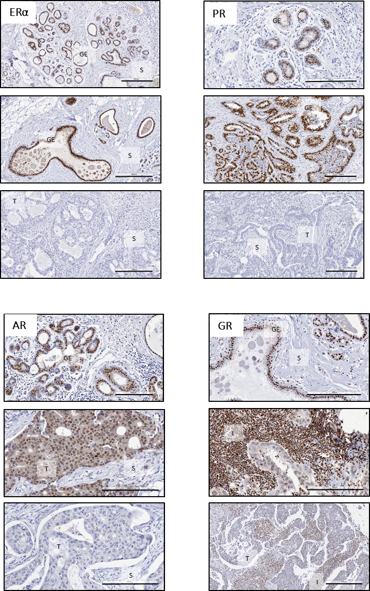
Figure 3 Steroid receptor staining in TNBC sections: Representative staining patterns for ERα, PR, AR and GR, in regions of TNBC sections with different tissue architecture are depicted. Small scale bars = 300μm, large scale bars = 200μm. S = stroma, GE = glandular epithelium, T = tumour, I = immune cells.
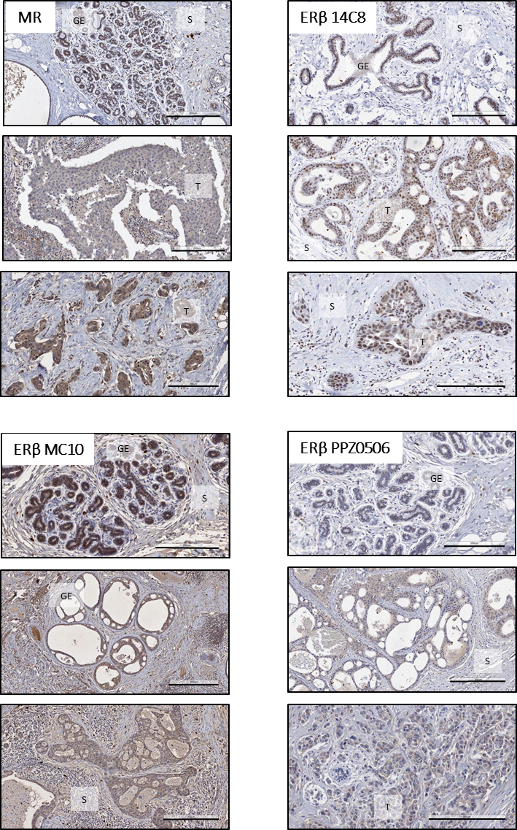
Figure 4 Steroid receptor staining in TNBC sections: Representative staining patterns for MR and the three different ERβ antibody clones, in regions of TNBC sections with different tissue architecture are depicted. Small scale bars = 300μm, large scale bars = 200μm. S = stroma, GE = glandular epithelium, T = tumour, I = immune cells.

3.1.2 Comparative steroid receptor staining serial sections

The architecture of the tissue in each block was variable. Serial sectioning allowed for visualisation of the same region of tissue, enabling direct comparison of multiple antibodies. Positivity for ERα and PR appeared most pronounced in glandular cells (figure 5), whereas GR, MR and ERβ expression was most expressed in tumour cells (figure 6),
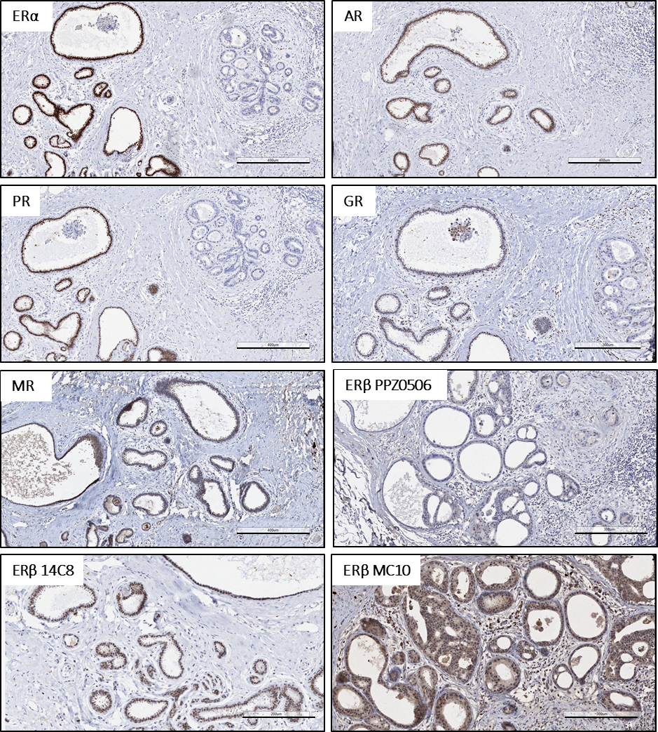
Figure 5 Comparison of steroid receptor staining: Images depict serial sections of a region of normal glandular breast tissue within a single TNBC case, stained for the six different steroid receptors, as labelled. Scale bar = 400μm.
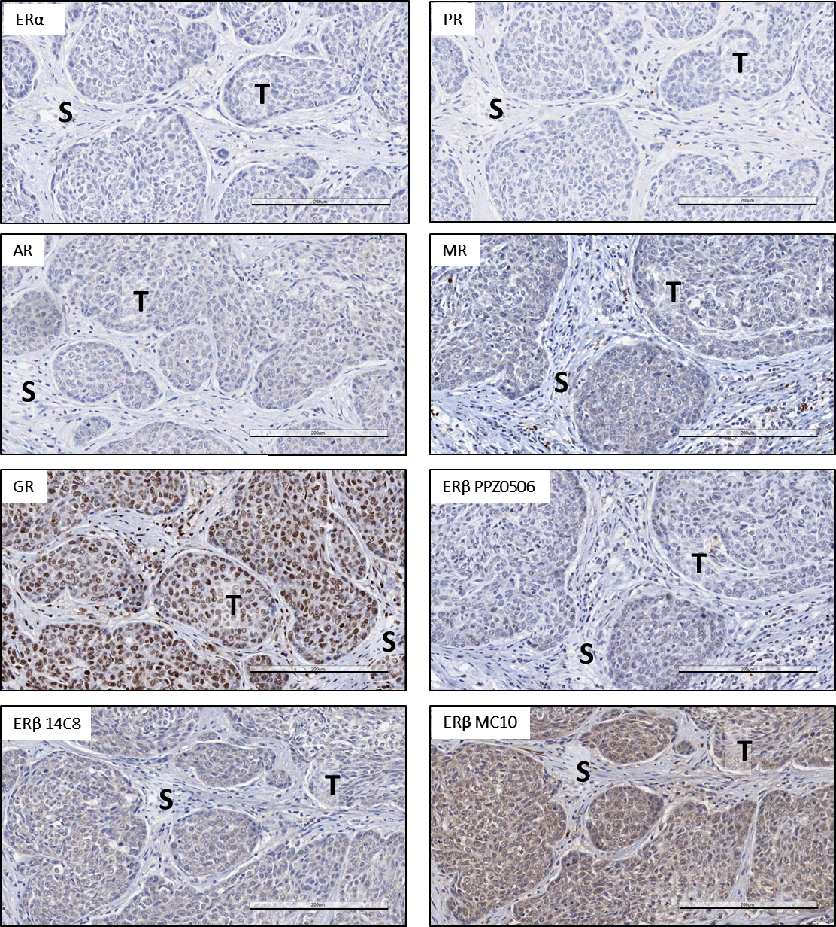
Figure 6: Comparison of steroid receptor staining: Images depict serial sections of a region of tumour tissue within a single TNBC case, stained for the six different steroid receptors, as labelled. T = tumour cells and S = stroma. Scale bar = 200μm.

3.1.3 Testing different ERβ antibody clones
The most commonly used (and published) ERβ antibody, the 14C8 clone, had the greatest intensity of positivity within the tumour regions, with absence in surrounding stroma. On balance it appears that clone I4C8 and PPZ0506 are more specific, but that 14C8 has higher affinity.
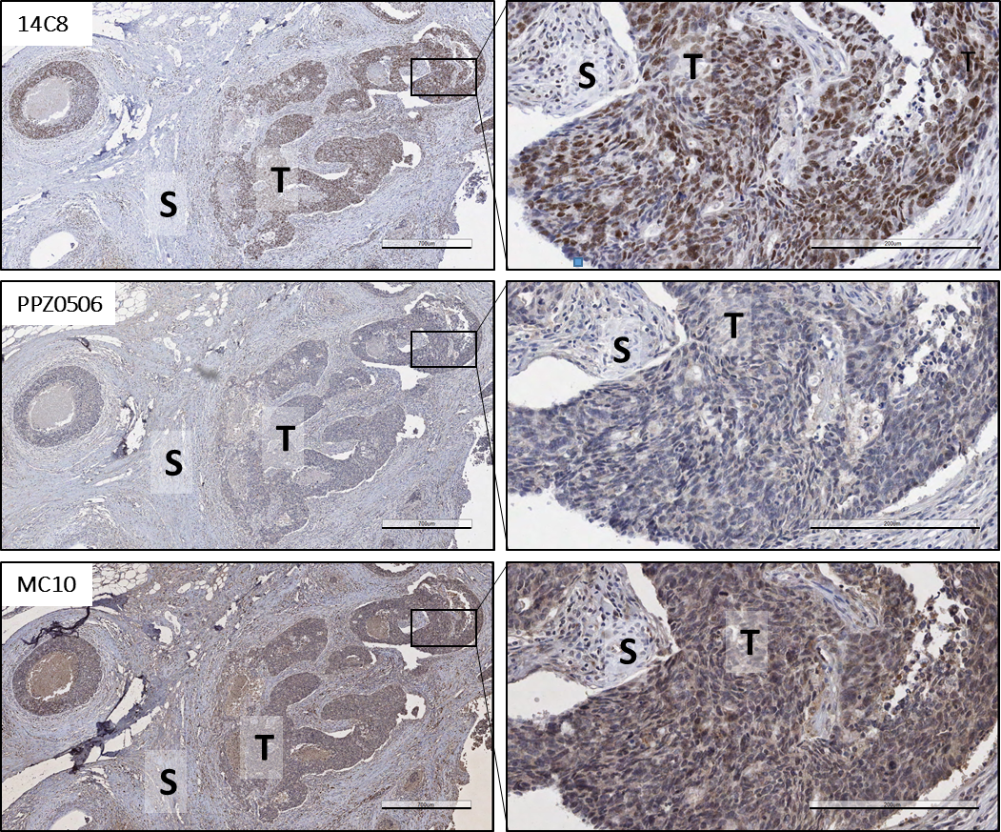
Figure 7 Comparison of staining using the three ERβ antibody clones: Serial sections of TNBC showing the relative staining patterns for each of the 3 different ERβ antibody clones tested. The same section is shown at two different magnifications. Boxes indicate expanded regions. Left hand column scale bar = 700μm and right hand column scale bar = 200μm. T = tumour, S = stroma.

3.2 Quantification of steroid receptor expression levels in TBNC

3.2.1 Image analysis using QuPath
Quantification of stained sections was achieved using the QuPath computer algorithm. Although the process of establishing the application was time consuming and laborious, the ability to refine and adapt the program was beneficial. Images of the process of training and applying the algorithm are shown in figure 8 with examples from the TMA (figure 8a). QuPath uses DAB staining intensity to determine the extent of positivity in the cells (figure 8b).
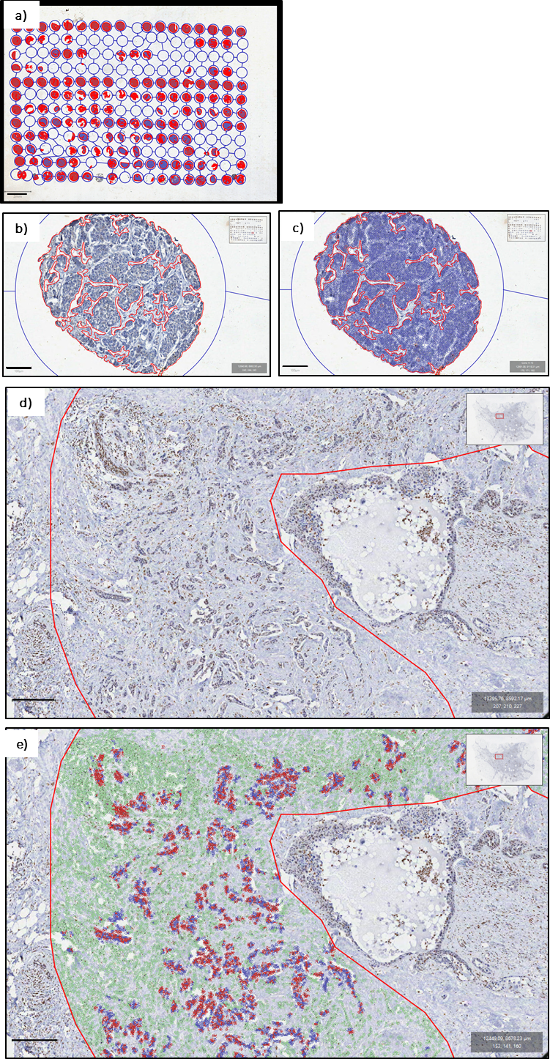
Figure 8 Use of the QuPath computer program for quantifying IHC staining: Stained sections include TMA arrays (a-c) were analysed using QuPath which identifies regions and calculates percentage of positive cells. Deep learning was then be applied to detect different cell types within the region shown in (d). In this example (e), QuPath identified regions of stroma in green, immune cells in purple, positive tumour in red and negative tumour in blue. The program can recall these annotations in subsequent sections. Scale bars; a) = 2mm, b) and c) = 100μm, d) and e) = 250μm.

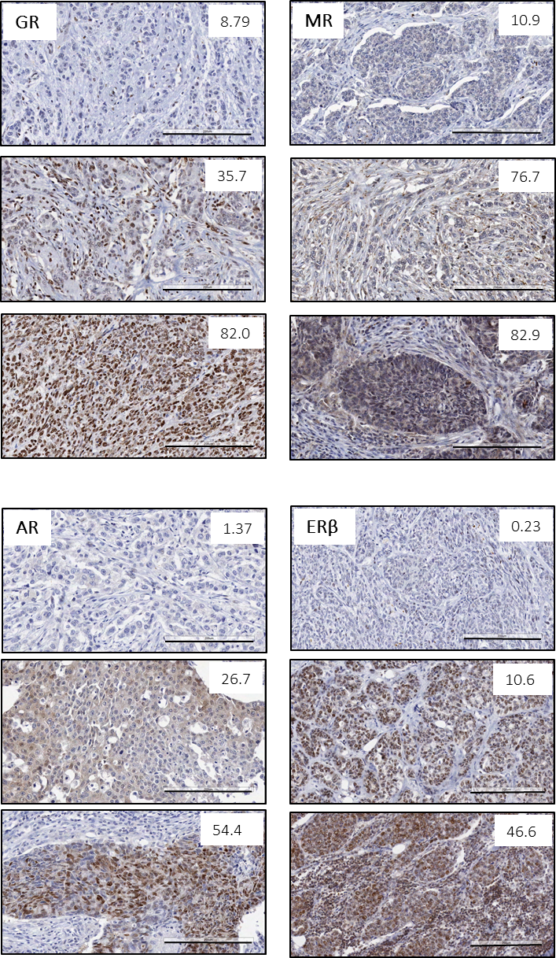
Figure 9 Steroid receptor quantification using QuPath: Shown are a selection of images exemplifying some of the values generated by the QuPath program for % positivity of tumour cells based on the intensity of brown DAB staining (values shown are percentage positives within the field). Scale bar = 100μm.

3.2.2 Steroid receptor expression in TNBC tumours
The values of steroid receptor positivity specifically in tumours are outlined in figure 10. There was no clear pattern in expression of the four receptors dependent on clinical outcome, although some of the samples from aggressive tumours that caused death are positive for GR, MR, and ERβ but were negative for AR. Larger numbers are required in each group to definitively prove this observation.
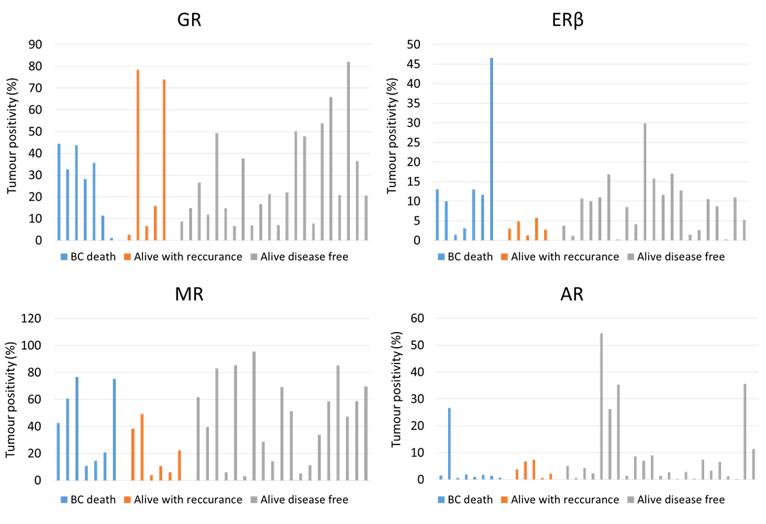

Figure 10: Steroid receptor expression in TNBC sections: Bar graphs depict the proportion of TNBC tumour cells positive for GR, ERb, MR and AR generated by the QuPath analysis. Each bar represents and individual case, which is colour coded based on clinical data as death from TNBC, alive with recurrence, or alive and disease free, as indicated. Average expression of each steroid receptor is shown in the bottom graph.

3.2.3 Pairwise correlation of steroid receptor expression in TNBC sections
Significant crosstalk signalling occurs between different steroid receptors, and recent evidence suggests that the activity of one can influence another. This was explored here by the pairwise comparison of the expression of the different steroid receptors investigated. Little correlation was observed for each of these pairwise comparisons (figure 11).
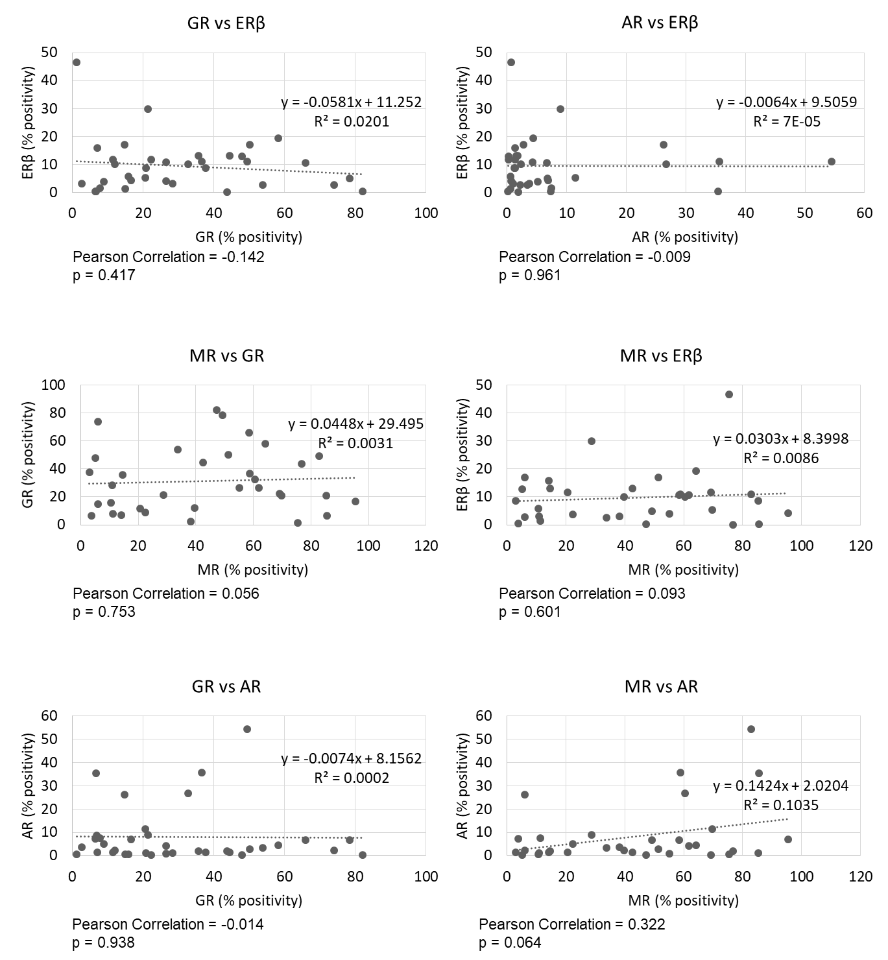
Figure 11 Correlation of steroid receptor expression in all TNBC sections: Percentage of tumour cell positivity was calculated for AR, GR, MR and ERβ in 39 TNBC cases using QuPath program. These values were then plotted by pairwise comparison to assess any correlation in steroid receptor expression.

3.3 Correlation of steroid receptor expression and disease progression
Kaplan Meier (KM) plots were generated in order to assess whether steroid receptor expression was predictive of disease progression in the TNBC patients. A trend for decreased overall and disease free survival with high GR expression is seen, however this is not significant, and more samples would be needed to confirm this relationship. No statistical significance is shown for either endpoints based upon high or low expression of ERβ and MR.
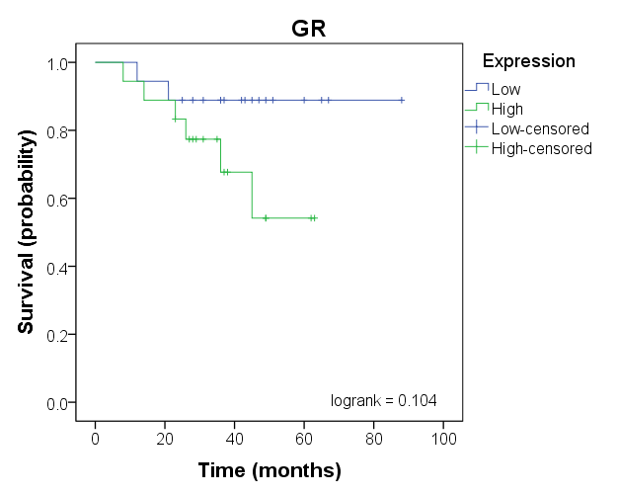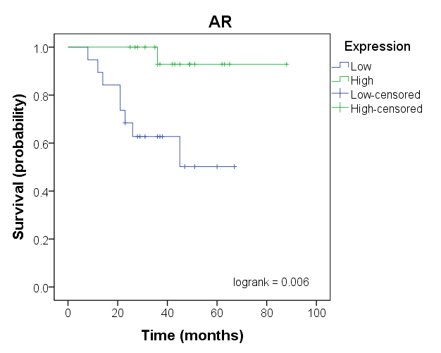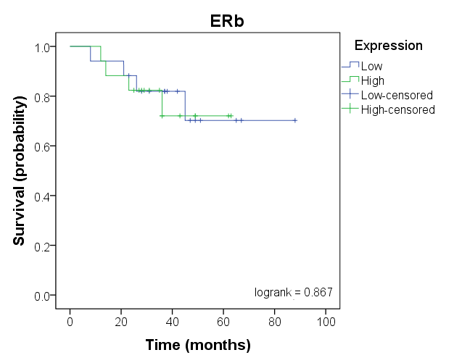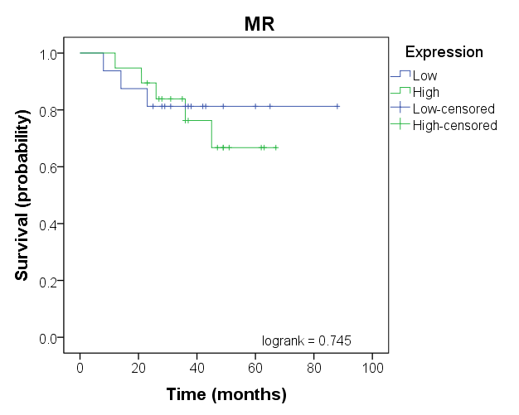
Figure 12 Correlation of steroid receptor protein expression and survival: Kaplan Meier plots for overall survival generated from QuPath data obtained from the 39 TNBC cases analysed in this study using SPSS. Lines indicate high (green) vs low (blue) tumour expression. Data for ERβ expression was based on the detection of the 14C8 clone binding.
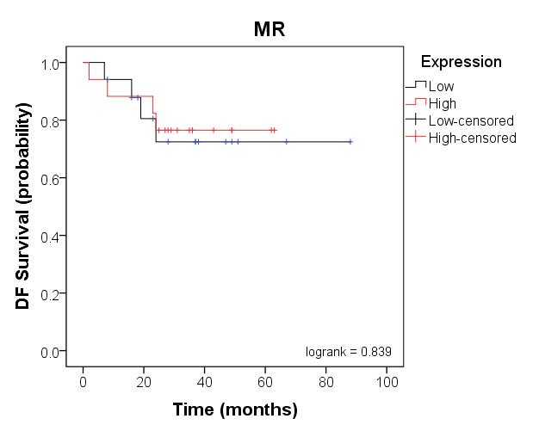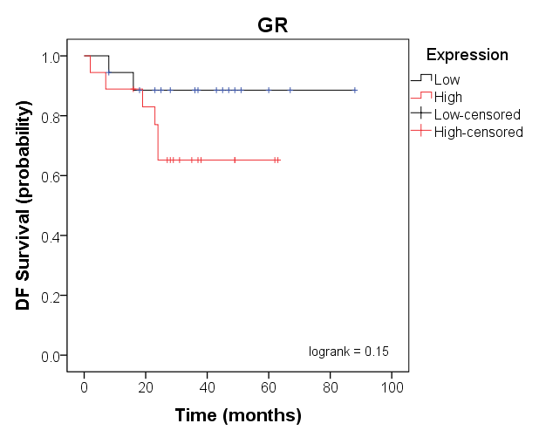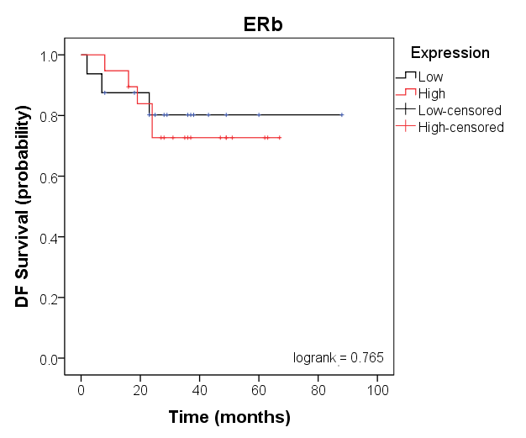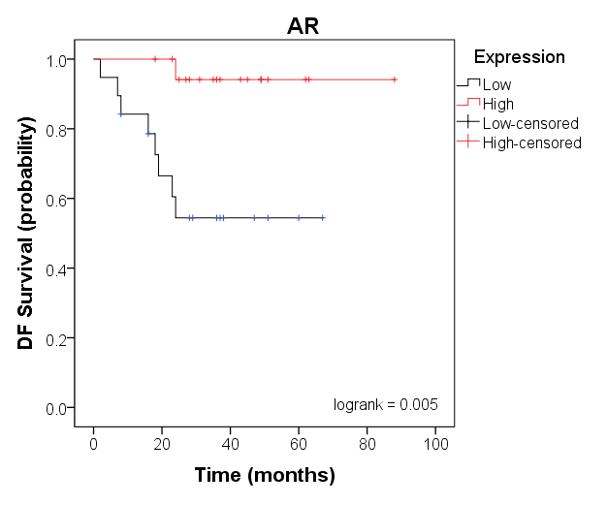
Figure 13 Correlation of steroid receptor protein expression and disease free survival: Kaplan Meier plots for disease free survival survival generated from QuPath data obtained from the 39 TNBC cases analysed in this study using SPSS. Lines indicate high (red) vs low (black) tumour expression. Data for ERβ expression was based on the detection of the 14C8 clone binding.

3.4 Developing a model to study steroid receptor crosstalk in TNBC

3.4.1 Steroid receptor expression in cell lines
In order to explore the role of GR and AR in controlling TNBC function, steroid receptor expression profiles of the two standard BC cell lines were compared. Formalin-fixed paraffin-embedded pellets of cells grown in 2D were cut and used to determine receptor expression by IHC. GR was strongly expressed in both cell lines, and AR was expressed in the cytoplasm, most prominently in the MDA-MB-231 cell line.
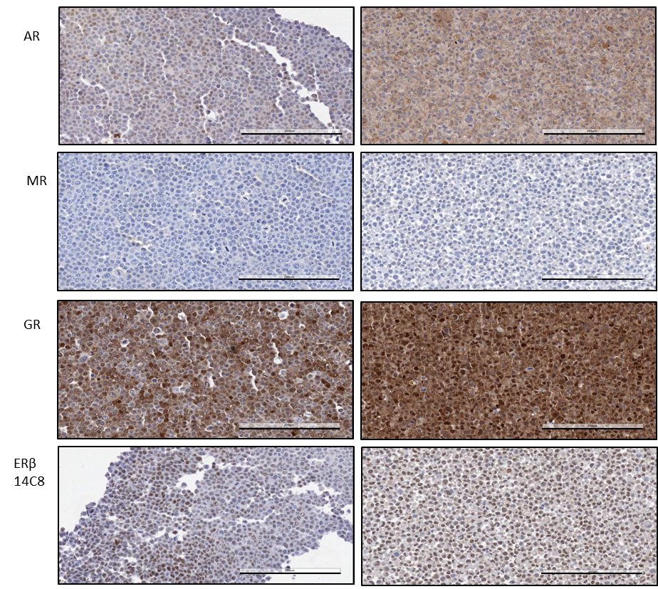
Figure 14: Expression of steroid receptors in sections of 2D cell pellets: MCF-7 (left)and MDA-MB-231 (right)cells were cultured in 2D monolayers, then trypsinised, pelleted and fixed in 4% PFA. Pellets were paraffin embedded, section and stained using antibodies specific to PR, Era, AR, MR, GR, ERb as indicated. Steroid receptor expression is shown in brown, and nuclei counterstained in haemotoxylin. Scale bar = 100μm.

3.4.2 Developing a 3D spheroid model
Traditional in vitro models of breast cancer have utilised well-established cell lines cultured in 2D monolayers, with cell growth maintained by adherence to the surface of a cell culture flask. However significant limitations for the accurate modelling of natural tumour development exist with 2D culture (5, 8, 9).

3.4.3 Steroid receptor staining of spheroid culture
The aim was to compare the expression levels of the four steroid receptors in both the 2D and 3D cell models, and secondly, to see if there was a change in expression between the central and outer parts of the spheroid.
Cells within the spheroids appeared to stain more selectively as opposed to the uniform staining observed in the 2D cell pellet examples, this was especially seen in the larger spheroids, and is particularly obvious in the close up images in figure 16.
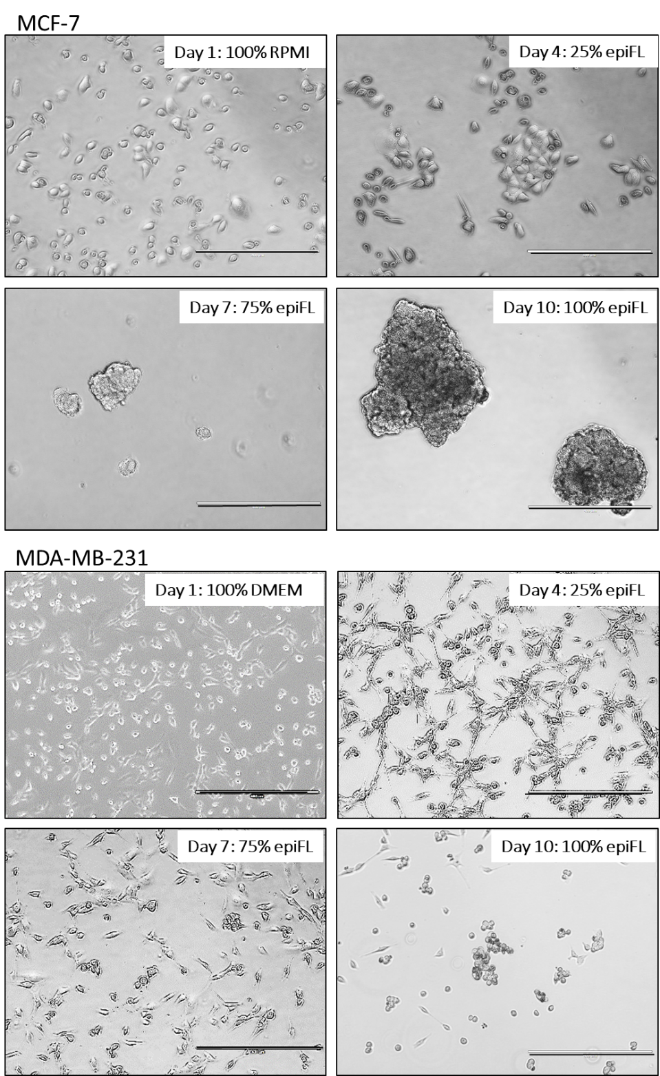
Figure 15: MCF-7 and MDA-MB-231 cells were transferred from standard media into 100% epiFL through gradually increasing ratios of the 3D culture medium epiFL over a period of 10 days.
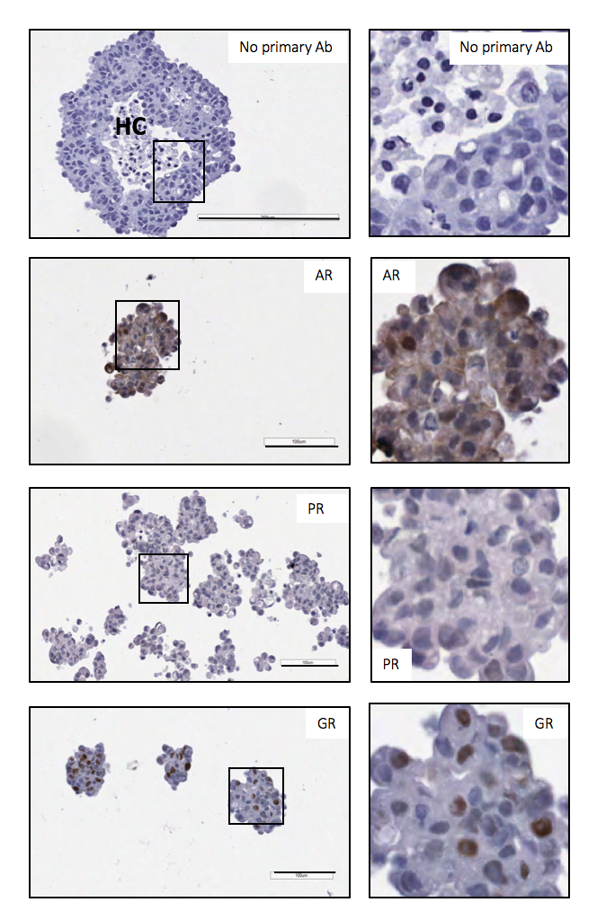
Figure 16: MCF-7 cells were cultured in epiFL culture media for 14 days until spheroids formed. Spheroids were then fixed, embedded and cut into 5μm sections and stained for steroid receptor expression using specific antibodies as indicated. Steroid receptor expression is shown in brown and negative nuclei stained blue. HC = hypoxic core, large scale bar = 200μm and small scale bar =100μm. Zoomed images are selected regions are shown on the right hand side.

4.0 Discussion

4.1 Staining of TNBC sections

This study sought to utilise breast tumour tissue sections and breast cancer cell lines in 3D models to investigate patterns of steroid receptor expression in TNBC, a disease which currently has no targeted treatment beyond standard chemotherapies. By using IHC as the main experimental method of investigation, it has been possible to visualise regions of positive and negative receptor expression in serial tumour sections, to identify co-expression profiles of steroid receptors within TNBC tumours. It has also been possible to look at intracellular staining patterns (nuclear or cytoplasmic regions) of steroid receptors, providing some measure of the transcriptional potential of the steroid receptors.

4.2 Survival analysis and therapeutic implications

Quantification using the QuPath software enabled objective conclusions of steroid receptor expression rate and survival to be drawn. This approach lead to several conclusions being drawn; that low GR and high AR were associated with longer overall survival and disease free survival, that ERβ or MR expression showed little effect.
The initial hypothesis proposed for this study was that targeting ERα and PR related steroid receptors may provide an alternative route for therapy. The outcome predictions described here provide further insight into the therapeutic influences that the NRs tested may have. It is possible, based on my data to predict that a combined therapy of AR agonists, coupled with GR antagonists might offer additional therapeutic benefit to treat TNBC.

4.3 Cell models

The cell models provided a validation of the results obtained by tissue staining. The limitations of 2D cell models have been discussed here and represent an opportunity for new technologies and innovation in optimising breast cancer in vitro research.

5.0 Conclusions and future work
This study suggests that two steroid receptors – androgen and glucocorticoid receptors may have opposing roles in determining the outcome of TNBC. Future studies are needed to fully characterise this relationship, and identify new therapeutic strategies.
- Increase the number of patient samples
- Testing additional cell lines
- Testing steroid receptor ligands

6.0 References

1. Louie MC, MB S. Steroid hormone receptors as prognostic markers in breast cancer. American Journal of Cancer Research. 2017;7(8):1617-36.
2. Breast cancer statistics London: Cancer Research UK; 2015 [Available from: http://www.cancerresearchuk.org/health-professional/cancer-statistics/statistics-by-cancer-type/breast-cancer.
3. Beatson G. On the treatment of inoperable cases of carcinoma of the mamma: suggestions for a new method of treatment, with illustrative cases. The Lancet. 1896;148(3803):162-5.
4. Huggins C. Endocrine methods of treatment of cancer of the breast. Journal of the National Cancer Institute. 1954;15(1):1.
5. Holliday DL, Speirs V. Choosing the right cell line for breast cancer research. Breast cancer research : BCR. 2011;13(4):215-.
6. Ivanov DP, Grabowska AM. Spheroid arrays for high-throughput single-cell analysis of spatial patterns and biomarker expression in 3D. Scientific reports. 2017;7(1):41160.
7. Matthews LC, Berry AA, Morgan DJ, Poolman TM, Bauer K, Kramer F, et al. Glucocorticoid receptor regulates accurate chromosome segregation and is associated with malignancy. 2015.
8. Burdall SE, Hanby AM, Lansdown MRJ, Speirs V. Breast cancer cell lines: friend or foe? Breast cancer research : BCR. 2003;5(2):89-95.
9. Roberts S, Speirs V. Advances in the development of improved animal-free models for use in breast cancer biomedical research. Biophysical Reviews. 2017;9(4):321-7.

Supervisors:
Professor Valerie Speirs
Dr Laura Matthews
With special thanks to:
The Pathological Society of Great Britain and Northern Ireland
Breast Cancer Now Tissue Bank
Leeds Teaching Hospitals NHS Trust

Word count: 1974

