Emma Bennion-Pedley: Tick Immunity Research Internship Report:
Introduction:
I was able to take up the opportunity to undertake an 8-week lab research internship in Erol Fikrig’s Laboratory in the Yale School of Medicine, Connecticut. Fikrig’s lab investigates vector-borne diseases, particularly Lyme disease, human granulocytic ehrlichiosis and West Nile virus. My internship was with the tick immunity group. The overall goal of this research currently is to identify specific proteins in tick saliva that can be used to induce tick rejection in animal models. The ultimate goal is to use these as constituents of a vaccine to prevent tick-borne diseases.
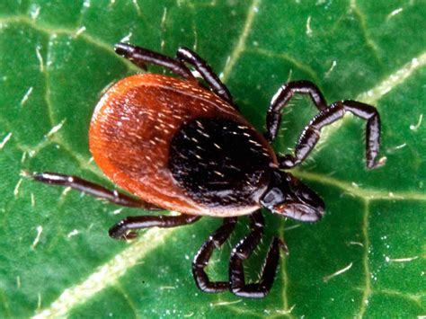
In North America, the black-legged tick, Ixodes scapularis, is a vector of several human pathogens including Borrelia burgdorferi, the Lyme disease agent, and of pathogens responsible for anaplasmosis, babesiosis and tick-borne encephalitis. Human vaccines against Lyme disease are not currently available. It has been established that repeated exposure of guinea pigs to ticks results in acquired resistance of the animals to subsequent tick bites, so-called ‘’tick immunity’’, and can influence transmission of tick-borne infections. This is since many of the tick salivary components (such as Salp15) have been shown to be essential for the successful transmission of Borrelia to mammalian hosts. This principle that salivary proteins aid the transmission of vector-borne pathogens is one that Fikrig’s group has also illustrated in work on Dengue virus, West Nile virus, and other flaviviruses.
Fig. 1. Ixodes Scapularis
Fikrig’s lab has already previously demonstrated using a guinea pig model, that immunity directed against salivary proteins expressed in the first 24h of tick attachment is sufficient to evoke all the hallmarks of acquired tick-immunity, to thwart tick feeding and also impair Borrelia transmission. The lab is now focussing on defining the subset of proteins that are critical for initiation of tick feeding and Borrelia transmission in hope of finding potential vaccine candidates. I was particularly interested in joining this overall project as I found the idea of a vector-based rather than pathogen-based vaccine intriguing. Also having had a neighbour at home suffer from complications of Lyme disease, and there being a higher prevalence of the disease in Dorset than many other parts of the UK, the issue particularly resonated with me.
My Involvement with the Project:
I was assigned a supervisor in the lab, who was responsible for teaching me a variety of necessary techniques needed for lab work as well as allocating me tasks to help towards the project. I spent most of my time learning from him, assisting with his experiments, and closer to the end of the internship carrying out my own procedures independently to provide some data for his work. As this was my first experience working in a lab, my supervisor focussed on exposing me to the large variety of techniques which I could learn and use for further possible lab placements, rather than giving me a single project.
Animal Experiments:
One of the aspects to which I was able gain a lot of exposure was the skills and techniques required for working with animals. Whilst the vast majority of the experiments involved Guinea pigs, I was also involved in some using mice and rabbits. This work quickly taught me skills in the handling of these different animals, setting up and cleaning out cages, shaving, anesthetising and carrying out tick challenge experiments. I also observed the techniques involved in vaccination, biopsy collection, bleeding and euthanising of these animals, although I was not able to practise these myself. I assisted with a number of tick challenge experiments. These involved infesting guinea pigs with ixodes ticks in order to induce tick immunity. The hallmarks of this involve impaired (prolonged) feeding, reduced engorgement (measured by weighing) and erythema around the bite sites. We then planned to use these resistant pigs in cross-reactivity studies with other vector species, such as Dermacentor, Amblyomma and Rhipicephalus, to determine the extent of the protection granted towards other species.
Fig. 2. Different American Tick Species
We also carried out tick feeds on guinea pigs and rabbits using Haemaphysalis ticks, an Asian species traditionally known as a livestock pest but becoming an increasing problem being associated with transmitting several other tick-borne diseases in humans. This was to determine whether this species fed well on lab animals and thus whether it might be worth establishing a colony for use as part of the cross-reactivity studies. As a side project, we also carried out tick challenges on mice using ixodes scapularis larvae (the most antigenic life stage). This was part of an ongoing attempt by my supervisor to show tick resistance in mice (despite general scientific consensus that mice do not exhibit tick immunity, a few papers suggest it may be possible with some species and life stages of ticks). These experiments allowed me to learn the contrasting techniques involved in working with different animal models as well as how to transfer ticks safely and successfully using brushes.
In addition to the tick challenges, we carried out several vaccinations using midgut and salivary proteins as well as heat treated salivary proteins and ‘cement cones’. Tick cement is a substance of particular interest to my supervisor. It is a secreted substance thought to be derived from saliva that acts as a strong adhesive between the mouth parts of the tick and the skin at the bite site. The amount secreted varies greatly between species and life stages. As this substance is secreted very early on in feeding and makes direct contact with the host, he believes it may play a key role in inducing tick immunity early on. The process of extracting the material for these different vaccines was a lengthy process, involving many hours of tick dissection. I had to first learn the anatomy of different tick species and then the techniques of dissecting using needles under a microscope. This was something I definitely improved at over time. The different components were then placed in trizol and the protein concentration subsequently analysed using a nanodrop machine. Cement was particularly difficult to produce a concentrated enough solution due to its very poor solubility. Once we determined we had sufficiently pure and concentrated samples, we prepared vaccines by suspending the preparations in incomplete Freund’s adjuvant (an emulsion of oil, antigen and PBS) to solubilise the antigen and cause slower release. These were then delivered to the guinea pigs over a course of two months to produce immunity. Despite not carrying out the vaccinations myself, I learnt the importance of not delivering too large an amount to any particular subcutaneous site. This is due to the propensity of the guinea pigs to develop vaccination sores, which if judged severe must result in the pig being euthanised.
Fig. 3. Tick Dissection
Protein Cloning:
Another large proportion of my time spent at the lab was dedicated to learning the techniques of protein cloning. Prior to my arrival a number of potential vaccine candidates had been identified via mass spectrometry analysis of tick saliva. These needed to be cloned in order to produce the vaccines to trial in animal tick challenge experiments. My supervisor also wanted to clone a number of ‘cuticle proteins’ established in literature to be components of tick cement cones. This gave me an opportunity to learn a number of essential lab techniques involved in the initial stages of cloning, including RNA extraction, primer design, PCR, SDS Page, gel purification, bacterial transformation and plasmid purification (mini-prep). I also was able to learn western blotting and protein quantification from someone who was at the later stages of the process (eluting an already cloned protein for vaccine preparation). Carrying out these procedures a number of times helped me feel comfortable with the process and refine my technique. I also gained an appreciation for how time consuming the cloning process can be, given the likelihood of some steps failing at first and having to be repeated.
CD55 and Borrelia:
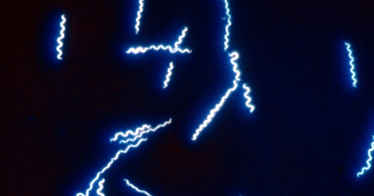
A member of the lab had previously shown through yeast display assay that the complement regulatory protein CD55 (also known as decay accelerating factor) interacted with surface proteins of Borrelia bacteria. My supervisor now had been assigned the task of proving this binding using an immunofluorescence assay (IFA). We used cultures of Borrelia Crocidurae and Persica species. I learnt how to re-culture these bacteria inside a biosafety cabinet as well as how to use dark field microscopy to monitor the growth of the cultures, distinguishing between live and dead spirochetes. Perhaps due to the species, our cultures were very slow growing leading to us having difficulty obtaining high enough concentrations for the assay. I learnt the techniques used to obtain lysate from these cultures as well as the steps involved in the IFA. However, despite trying the assay a number of times with different variations, even using a cytospin machine, we had difficult creating clear slides in which the spirochetes were visible. Therefore, after these failed attempts, my supervisor decided we should try to use an Elisa as a means of investigating the binding. Via coating the wells with lysate and using CD55 conjugated to human Fc as the primary antibody, we were able to obtain results to suggest that CD55 does indeed bind to Borrelia. It is thought that this may play an immunosuppressive action on the complement system of its host, facilitating transmission. My supervisor would like to obtain CD55 knockout mice in order to investigate whether there is any effect in impairing Borrelia transmission.
Fig. 4. Borrelia Spirochetes under Dark Field Light Microscope
What I learnt from the Internship:
I found the internship a very valuable experience in learning what it is like to work in a lab environment as well as in providing me with a baseline of skills which I can use if I undertake further research placements. I really enjoyed the hands-on nature of a lot of the research as well as its clear application to disease prevention. I was also able to practise presenting results of experiments at lab meetings. This internship has strengthened my interest in a career in a possible career in pathology or at least in carrying out some form of research alongside practising clinical medicine. The fact that the internship was abroad made it an interesting cultural experience as well, allowing me to spend weekends exploring Connecticut and the local area as well as learn about perspectives of what it is like to live and work in the US.
I am hugely grateful for receiving the Pathological Society Undergraduate Bursary in support of carrying out this internship, contributing towards my accommodation, flights and visa costs. This extra money alleviated the stresses of working long hours over the university holidays to cover the costs, meaning that I could focus more on balancing my academic work and resting over the break. I cannot stress enough how thankful I am for receiving this generous financial support.

